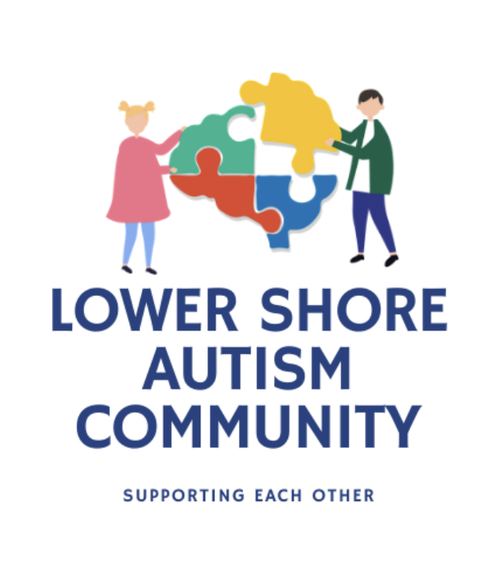

RESOURCE GUIDE

TABLE OF CONTENTS
Autism Friendly Services 3
Speech & Occupational Therapists 5
Education 7
early intervention 8
legal 9
support 10
healthcare 11
community programs 13
transportation 15
childcare 16

Autism Friendly Services

Wicomico County

Dove Point
Provides Autism Support Services
1225 Mt. Hermon Rd, Salisbury
410-341-4472
dovepointe.org

United Needs and Abilities
Provides Residential Services, Personal Supports, Mentoring Services, and Vocational Support
688 E Main St., Salisbury
410-543-0665
una1.org

Bay Area Center for Independent Living
Promotes access to community resources and support for people with disabilities and their families
909 Progress Cir Ste 300, Salisbury
443-260-0822
bayareacil.org

Easter Seals
Provides Autism Services
1336 Belmont Ave, Salisbury
410-546-2894
easterseals.org/de

Niki Runge, Music Therapist
Music Therapy Services
212 E. Main St. Suite 211, Salisbury
443-523-4976
facebook.com/salisburymusictherapy

Innovative Piano
Piano lessons utilizing ABA
6225 Westbrooke Drive, Salisbury
443-944-8237
innovativepiano.com

4Steps Therapeutic Riding Program
Therapeutic Riding Program for children and adults with disabilites
5367 Sixty Foot Road, Parsonsburg
410-835-8818
4stepstrp.org

Worcester County

Ocean Front Counseling
Provides a variety of services such as ABA, Respite, Individual Support Services, Behavior Support Services, and more
10514 Racetrack Rd Ste G, Berlin
410-973-2301 / oceanfrontcounseling.com

Statewide

Virtual Field Trips
A comprehensive list of virtual field trips available for free
https://pathfindersforautism.org/coronavirus-virtual-trips/

Spirit Club
Accessible live and on-demand virtual fitness classes with a ‘pay what you can’ payment model.
spirit-club.com/

Speech & Occupational Therapists

Wicomico County

Beverly Rodriguez, CCC-SLP (Willards Elementary School)
36161 Richland Rd, Willards
410-677-5819

Carolyn Knollman, Occupational Therapy (Easterseals)
1336 Belmont Ave #502, Salisbury
289-441-0546

Dana Harrington, SLP (Prince Street Elementary School)
400 Prince St, Salisbury
410-677-5813

Donna Adams, SLP (Glen Avenue Elementary)
1615 Glen Ave, Salisbury
443-783-3505

Megan Insley, SLP (North Salisbury Elementary School)
1213 Emerson Ave, Salisbury
410-677-5807

TidalHealth Peninsula Regional Medical Center (12 OT Providers, 10 SLP Providers)
100 E Carroll St, Salisbury
410-546-6400

Maryanne Kirchner, SLP & Kathleen Townsend, CCC-SLP (Wicomico County Public Schools)
101 Long Ave, Salisbury
410-677-5250 & 410-677-5178

Nicole R. Bergstrom, OTR
2009 Northwood Dr, Salisbury
410-603-5884

Robert Scherr, SLP
105 Pine Bluff Rd #8, Salisbury
410-749-7804

Salisbury Speech Therapy (2 Providers)
1502-D Pemberton Dr, Salisbury
410-572-4351 / salisburyspeech.com

Somerset County

Audrey Barrett, OTR & Heather Esham, SLP (Somerset County Public Schools)
7982a Tawes Campus Dr, Westover
410-651-1616

Beverly Beckett, OTR (McCready)
201 Hall Hwy, Crisfield
410-968-1200

Casey Abbott, Occupational Therapy (Woodson Elementary)
281 Woodson School Road, Crisfield
410-986-1295

Karen Baer, SLP (Princess Anne Elementary)
15576 Lankford Ave, Princess Anne
410-651-0481

Robey French, SLP (Crisfield High School)
210 N Somerset Ave, Crisfield
410-968-0150

Worcester County

Brittany Brody, OT & Christine Wall, CCC-SLP (Worcester County Board of Ed)
6270 Worcester Hwy, Newark
410-632-5000 & 410-632-5037

Jamie Kelly & Elizabeth Bodley, SLP & Kathy Lueders, OT (Showell Elementary)
11318 Showell School Rd, Berlin
410-632-5350

Jennifer Baker, SLP (Snow Hill Elementary)
515 Coulbourne Ln, Snow Hill
410-632-5210

Julie Baynard, MS Occupational Therapy (Cedar Chapel Special School)
510 Coulbourne Lane, Snow Hill
410-632-5230

Monica Perella, MA Speech Therapy (Stephen Decatur Middle School)
9815 Seahawk Rd, Berlin
410-632-3400

Ocean Front Counseling (2 SLP Providers)
10514 Racetrack Rd Ste G, Berlin
410-973-2301
oceanfrontcounseling.com

Shannon Phillips, SLP (Pocomoke Elementary)
2119 Pocomoke Beltway, Pocomoke City
410-632-5130

Dorchester County

Susan Gilison, MOT (UM Shore Medical Center)
300 Byrn St, Cambridge
410-822-1000

Dorchester County Public Schools (2 SLP Providers)
700 Glasgow St, Cambridge
410-228-4747

Education

Wicomico County

Wicomico County Board of Education
711 Lake St, Salisbury
410-677-4400 / wcboe.org

Wicomico County Judy Center
Promotes school-readiness in children ages 0-5
101 Long Avenue, Salisbury
410-677-5250
www.wcboe.org/Domain/2096

Somerset County

Somerset County Board of Education
7982A Tawes Campus Dr, Westover
410-651-2285 / somerset.k12.md.us

Somerset County Judy Center
Promotes school-readiness in children ages 0-5
11576 Lankford Street, Princess Anne
410-651-1275
somersetearlylearning.org/judy-center

Worcester County

Worcester County Board of Education
6270 Worcester Highway, Newark
410-632-5000

Worcester County Judy Center
Promotes school-readiness in children ages 0-5
515 Coulbourne Ln, Snow Hill
410-632-5224 / judycenter.com

Dorchester County

Dorchester County Board of Education
700 Glasgow St, Cambridge
410-228-4747

Dorchester County Judy Center
Promotes school-readiness in children ages 0-5
1405 Glasgow St, Cambridge
410-221-5268 /

Early Intervention

Wicomico County

Wicomico County Infants and Toddlers
900 Mount Hermon Road, Salisbury
410-677-5250

Early Head Start/Head Start, Shore Up!
Federally funded community-based programs for children 0-5. Serves Wicomico, Worcester, Somerset, and Dorchester counties.
520 Snow Hill Rd, Salisbury
410-749-1142 ext. 1092
https://shoreup.org/education/head-start/

Somerset County

Somerset County Infants and Toddlers
7982A Crisfield Highway, Westover
410-651-1485

Worcester County

Worcester County Infants and Toddlers
6270 Worcester Highway, Newark
410-632-5033

Dorchester County

Dorchester County Infants and Toddlers
700 Glasgow St, Cambridge
410-221-1111 ext. 1023

Legal

Wicomico County

Jamie L Dykes, Wicomico County State’s Attorney
309 E Main St, PO Box 1006, Salisbury
410-548-4800

Somerset County

Wess Garner, Somerset County State’s Attorney

30500 Prince William St, Princess Anne
410-651-3333

Worcester County

Kris Heiser, Worcester County State’s Attorney

106 Franklin St, Snow Hill
410-632-2166

Dorchester County

William H. Jones, Dorchester County State’s Attorney

501 Court Lane Suite 211, Cambridge
410-228-3611

Statewide

Disability Rights Maryland
Legal and advocacy services for Marylanders with disabilities.
Mail: 1500 Union Ave, Ste. 2000, Baltimore
410-727-6352
disabilityrightsmd.org

Support

Worcester County

Autistic Children’s Support Group Worcester County
Non-profit organization dedicated to providing parent-to-parent support for families living with Autism and related developmental disabilities.
410-352-5011
http://acsgwc.org/

Healthcare

Wicomico County

Krause Smiles
Dentistry practice for children ages 1-21 and patients with special needs of all ages.
560 Riverside Drive, Suite A-205, Salisbury
410-742-1688
krausesmiles.com

Gateway Pediatrics
1415 Wesley Drive, Salisbury
410-912-7000
gatewaypediatrics.com

Chesapeake Pediatrics
106 Milford St, Salisbury
410-543-1616
chesapeakepeds.com

Ansari Pediatrics
106 Pine Bluff, Salisbury
410-742-2255
ansaripediatrics.com

Eastern Shore Pediatrics
211 Maryland Ave
410-219-9111
easternshorepeds.com

Jose Alvarado & Associates
1208 Pemberton
410-742-7660
alvaradoandassociates.com

Chesapeake Health Care Pediatrics
223 Phillip Morris Dr, Salisbury
410-548-1747
chesapeakehc.org

Somerset County

Chesapeake Health Care
Pediatrics, Mental Health, Adult Medicine, OBGYN & Lab
12145 Elm St, Princess Anne
410-651-1000
chesapeakehc.org

Princess Anne Family Practice
30434 Mt Vernon Rd, Princess Anne
410-651-0350
princessannefamilypractice.com

Eastern Shore Psychological Services
11120 Somerset Ave. Princess Anne
410-651-4200
espsmd.com/

Worcester County

Kennedy Krieger
9714 Healthway Dr. Berlin, MD 21811
(410)-629-6881
kennedykreiger.org

Atlantic General Pediatrics
Lists Autism as a service category
12308 Ocean Gateway, Ocean City
410-641-1100
atlanticgeneral.org/locations/atlantic-general-primary-pediatrics/

Chesapeake Health Care
9956 N. Main St. Berlin
410-972-2820
chesapeakehc.org

Dorchester County

Ambalapetta Vasudevan, MD
Pediatrics
320 Shipyard Dr Lot 42, Cambridge
410-221-2959

UM Shore Regional Health – Pediatrics 400 Byrn St., Cambridge
410-228-6161
umms.org/shore/smg/services/pediatrics

Community Programs

Wicomico County

Lower Shore Enterprises, Inc
Works to place individuals with disabilities from Dorchester, Somerset, Wicomico and Worcester Counties into jobs in the community.
28475 Owens Branch Road, Salisbury
(410)-749-6183
lseworks.org

United Way of the Lower Eastern Shore
803 N Salisbury Blvd Ste 2100, Salisbury
410-742-5143
uwles.org

Wicomico County Department of Social Services
201 Baptist St Ste 27, Salisbury
410-713-3900
dhs.maryland.gov/local-offices/wicomico-county/

Wicomico County Health Department
108 E Main St, Salisbury
410-749-1244
wicomicohealth.org

Somerset County

Somerset County Department of Social Services
30397 Mt. Vernon Road, Princess Anne
(410)-677-4200
dhs.maryland.gov/local-offices/somerset-county/

Somerset County Health Department
8928 Sign Post Road, Westover
(410)-523-1700
somerset health.org

PNC Bank Grow up Great
For children birth to 5 to promote school, social, and life skills.
38389 Mt. Vernon Road
Princess Anne, MD 21853
(410)-651-2404
www.pnc.com

Worcester County

Worcester County Health Department
13070 Saint Martins Neck Rd, Bishopville
410-641-9559
worcesterhealth.org

Worcester County Department of Social Services
299 Commerce Street, Snow Hill
410-677-6800
dhs.maryland.gov/local-offices/worcester-county/

Dorchester County

Dorchester County Health Department
3 Cedar St, Cambridge
410-228-3223
dorchesterhealth.org

Dorchester County Department of Social Services
627 Race Street, Cambridge
410-901-4100
dhs.maryland.gov/local-offices/dorchester-county

Transportation
Wicomico County

Medical Assistance Transportation
Provides complimentary, non-emergency transportation to qualified Medical Assistance Recipients.
410-548-5142
wicomicohealth.org/medical-assistance-transportation/

Somerset County

Medical Assistance Transportation
Provides complimentary, non-emergency transportation to qualified Medical Assistance Recipients.
443-523-1722
somersethealth.org/medical-assistance-transportation/medical-assistance-transportation-overview/

Worcester County

Medical Assistance Transportation
Provides complimentary, non-emergency transportation to qualified Medical Assistance Recipients.
410-632-0092
worcesterhealth.org/get-help-menu/113-transportation

Dorchester County

Medical Assistance Transportation
Provides complimentary, non-emergency transportation to qualified Medical Assistance Recipients.
410-901-2426
dorchesterhealth.org/medical-assistance-transportation/

Child Care

Wicomico County

Lower Shore Child Care Resource Center
Works with parents, childcare providers, early educators, businesses and
community organizations to help promote the availability of quality childcare services in Somerset, Worcester, and Wicomico counties.
East Campus Complex, Wayne St #500, Salisbury
(410)-543-6650
www.lowershoreccrc.org

Statewide

Child Care Subsidy
Provides financial assistance with childcare costs to eligible working families
1-(866)-243-8796
msde.maryland.gov/MSDE/divisions/child_care/subsidy/

Maryland Family Network’s LOCATE: Child Care for Special Needs
A free service funded by the Maryland State Department of Education to help qualified families find and procure child care.
1-(877)-561-0060
marylandfamilynetwork.org/for-parents/locate-child-care-special-needs

